

No. CANEC2105982401 Date: 20 Apr 2021 Page 1 of 4

PROVINCE CHINA

The following sample(s) was/were submitted and identified on behalf of the clients as : Aluminum jar SGS Job No. : CP21-016625 - GZ

Date of Sample Received : 14 Apr 2021

Testing Period : 14 Apr 2021 - 19 Apr 2021

Test Requested : Selected test(s) as requested by client.

Test Method : Test Results :

Please refer to next page(s). Please refer to next page(s).

Signed for and on behalf of

SGS-CSTC Standards Technical Services Co., Ltd. Guangzhou Branch



Sasa Zhi

Approved Signatory

Test Results :

Test Part Description :

Specimen No.. SGS Sample ID. Description. SN1 CAN21-059824.001 Silvery metal

Remarks :

(1) 1 mg/kg = 0.0001%

1. **MDL = Method Detection Limit**
2. **ND = Not Detected ( < MDL )**
3. **"-" = Not Regulated**

Elemental analysis, Hexavalent Chromium(Cr(VI)) .

Test Method : With reference to IEC 62321-4:2013+A1:2017, IEC 62321-5:2013, IEC 62321-7-1:2015,

analyzed by ICP-OES and UV-Vis .

|  |  |  |  |  |
| --- | --- | --- | --- | --- |
| **Test Item(s)** | **Limit** | **Unit** | **MDL** | ***001*** |
| **Cadmium (Cd)** | **100** | **mg/kg** | **2** | **ND** |
| **Lead (Pb)** | **1,000** | **mg/kg** | **2** | **5** |
| **Mercury (Hg)** | **1,000** | **mg/kg** | **2** | **ND** |
| **Hexavalent Chromium (Cr(VI))▼** | **-** | **µg/cm²** | **0.10** | **ND** |
| **Notes :** |  |  |  |  |

* 1. **The limit(s) was/were submitted by applicant.**
  2. **▼= a. The sample is positive for CrVI if the CrVI concentration is greater than 0.13 μg/cm². The sample coating is considered to contain CrVI**

b. The sample is negative for CrVI if CrVI is ND (concentration less than 0.10 μg/cm²). The coating is considered a non-CrVI based coating

c. The result between 0.10 μg/cm² and 0.13 μg/cm² is considered to be inconclusive - unavoidable coating variations may influence the determination

Information on storage conditions and production date of the tested sample is unavailable and thus Cr(VI) results represent status of the sample at the time of testing.

**ATTACHMENTS**

**Pb/Cd/Hg/Cr6+** **Testing** **Flow** **Chart**

1) These samples were dissolved totally by pre -conditioning method according to below flow chart. (Cr6+ test method excluded ).



1. Alkali Fusion / Dry Ashing
2. Acid to dissolve

Solution

ICP-OES/AAS

Residue



Separating to get aqueous phase

Digesting at 60°C by ultrasonication

pH adjustment

DATA

DATA

UV-Vis.

Adding 1,5- diphenylcarba zide for color development

Sample Preparation



**Cr6+**



**Pb/Cd/Hg**

Sample Measurement

Acid digestion with microwave / hotplate



Digesting at 150~160**℃**

Dissolving by ultrasonication

Filtration

Boiling water extraction

|  |  |
| --- | --- |
| Nonmetallic material | |
| C/PVC | Others |



Metallic material

ABS/P

DATA

Adding 1,5- diphenylcarbazide for color development

UV-Vis



Sample photo:

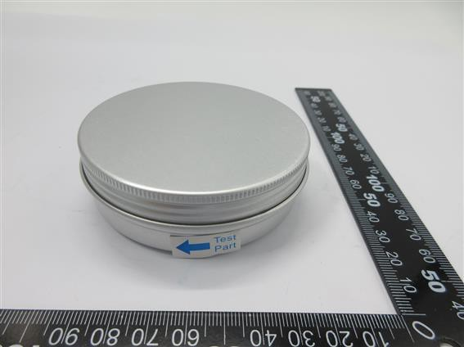

**CANEC2105982401**

**CAN21-059824.001**

SGS authenticate the photo on original report only

*** End of Report ***